**Agar Frogs Protocol**

**Materials (for 20 small frogs): 2 frogs /group at ~4 students /group.**

|  |  |  |  |
| --- | --- | --- | --- |
| 500ml tap H2O | 20 pre-programmed ibuttons | 1 Whisk or Spatula | 1L Pyrex measuring cup |
| 15g agar | 3 Weigh Boats | Scissors | Digital Scale |
| 6g pigment | Ball of cotton twine (string) | Duct Tape for labeling | Microwave |
| Agar frog mold |  |  |  |

**Protocol:**



**Figure 1**

1. Cut a piece of string 40cm (pre-cut by teacher).
2. Tie the string around the center of the ibutton and secure the string to the ibutton with a small piece of duct tape.
3. Obtain the agar frog mold. We need to place the ibutton in position on the mold before pouring the liquid agar mixture onto the mold. To do this, suspend the ibutton directly above one of the empty frog bodies in the mold. Stretch the string connected to the ibutton across the mold and secure the ends of the string to the table. Make sure the ibutton hangs in the center and does not touch the sides of the mold. See Figure 1 to the right. Attach a tape “label” to one end of the string with the ibutton number and group initials.
4. Mix 15g agar, 6g of desired colored pigment and 500mL tap water in the Pyrex measuring cup. Stir briskly with the whisk to ensure the powders are completely dissolved.
5. Using the microwave, heat the mixture in the Pyrex cup for ONE MINUTE. Remove the pyrex cup and stir well with the whisk. **NOTE: All microwaves heat with different powers. Carefully watch the liquid in the microwave for boiling. If the liquid begins to boil or bubble, STOP the microwave and continue to step 7. If it does NOT boil during the first minute, continue with step 6.**
6. Using the microwave, heat the mixture in the Pyrex cup again, this time for 30 SECONDS, or until boiling. **NOTE**: At some point, expect the mixture to boil vigorously towards the top of the container. If you notice the mixture starting to boil and filling the Pyrex cup, STOP the microwave, and carefully remove the cup. The cup and mixture will be very hot, so hold by the handle only. The teacher should complete this part of the protocol.

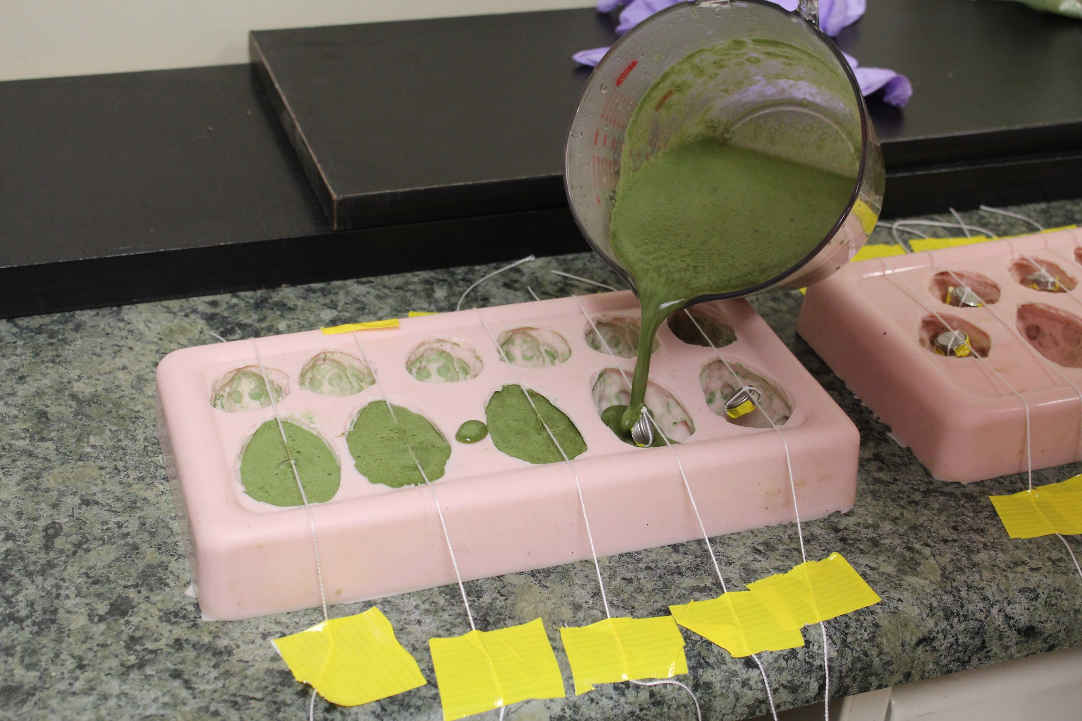

**Figure 2**

1. Stir the mixture again with the whisk and if all the agar seems to have dissolved (no chunks are seen on the side of the Pyrex if you swirl it around). If chunks remain, repeat steps 6 and 7.
2. Pour the mixture into the molds. Be sure to completely cover the ibutton. See Figure 2 to the right.
3. Let cool completely at room temperature before removing frogs from mold.